1. Open ShopPAK  
   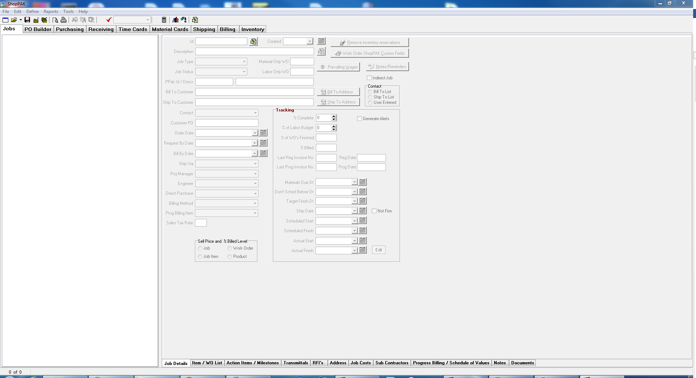
2. Open Small Hardware WO  
   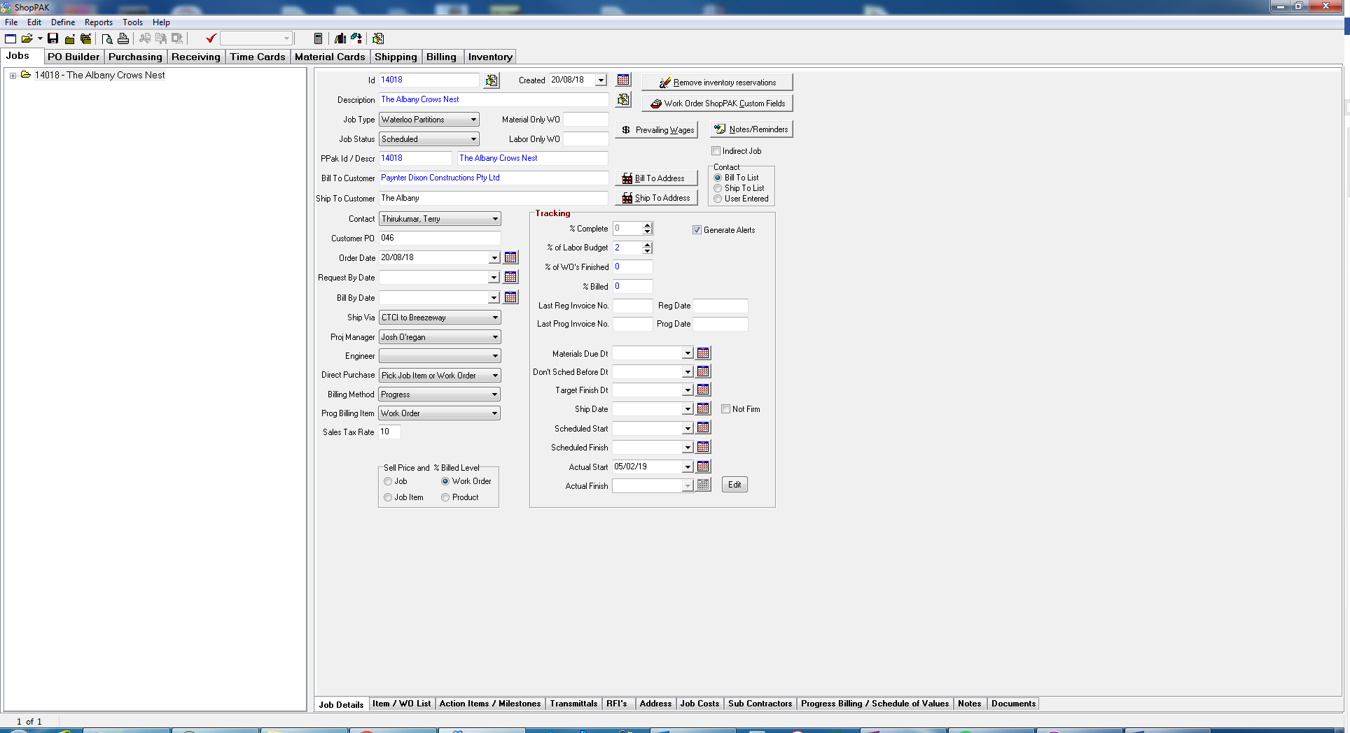
3. Open Action Items / Milestones tab  
   
4. Ensure that the milestones have been selected at the Work Order level.  
   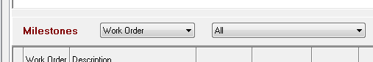
5. If this is a new order follow the below instructions to copy the Milestone Template. If this is further work for an existing order and the milestone template has already been copied then skip to step ???
6. Left click on top of Milestones grid to open menu  
   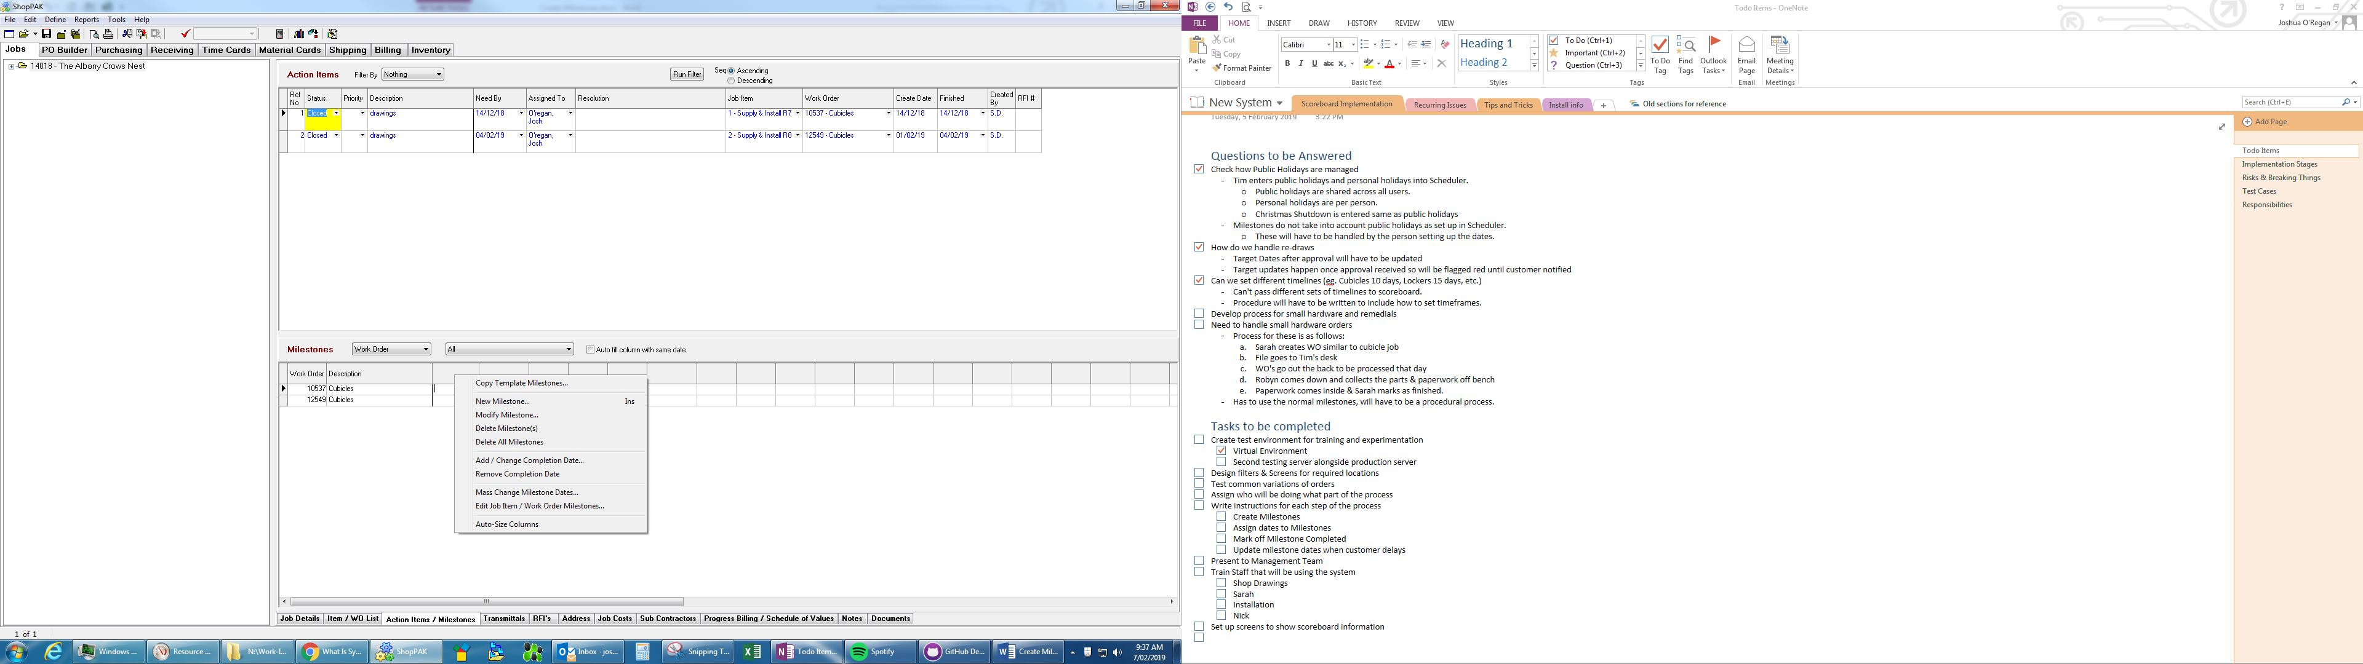
7. Select Copy Milestones Template  
   
8. Select the Cubicles, with yes in the scoreboard column. It is important to select the correct template as Scoreboard will only recognize one template  
   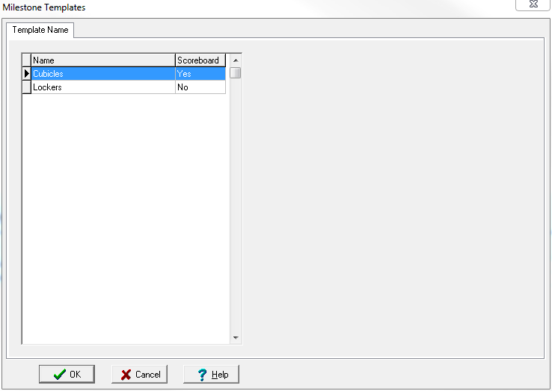
9. Milestones have been populated, ready for dates to be set.  
   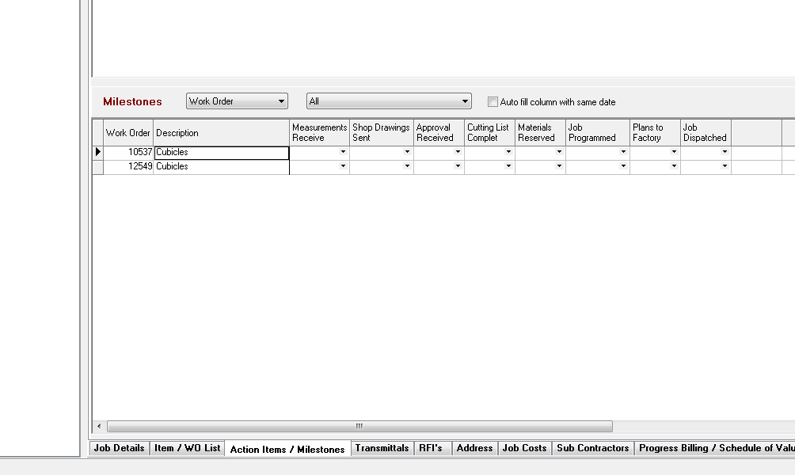
10. Right click the row for this small hardware WO  
    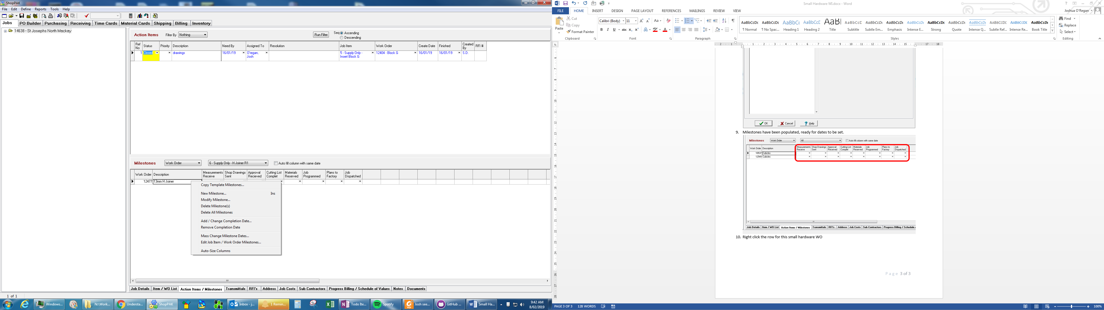
11. Click Edit Job Item / Work Order Milestones  
    
12. Click Adjust Job Item/WO Wait Days  
    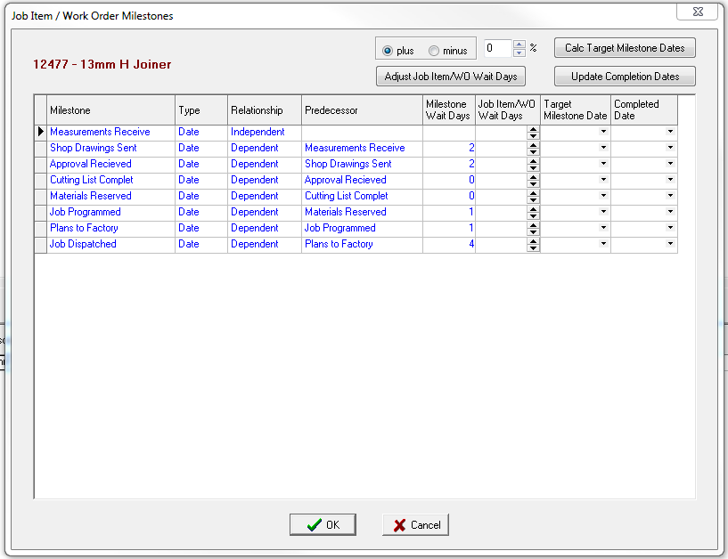
13. Set the Job Item/WO Wait Days to 0 for every Milestone except for Plans to Factory which is to be 1  
    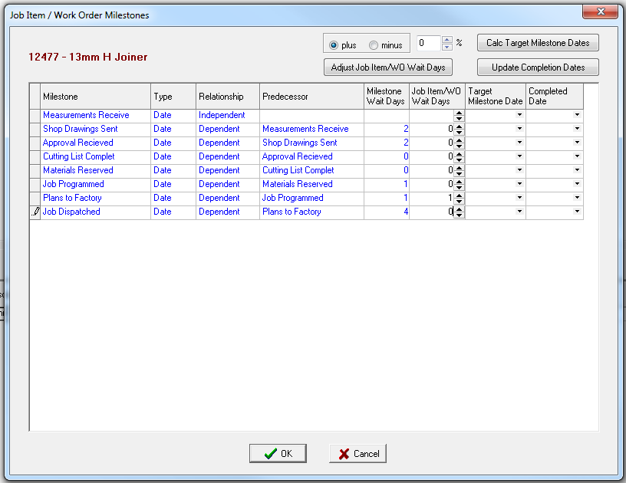
14. Set Target Milestone Date of Measurements Received to Today’s Date  
    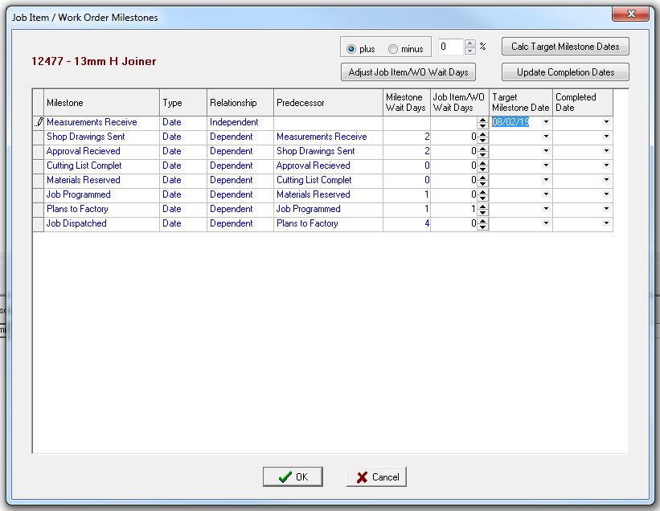
15. Click Calc Target Milestone Dates  
    
16. Skip Saturday and Sunday  
    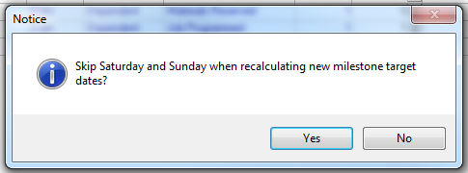
17. Highlight all Milestones to Job Programmed by selecting them in the LH grey column  
    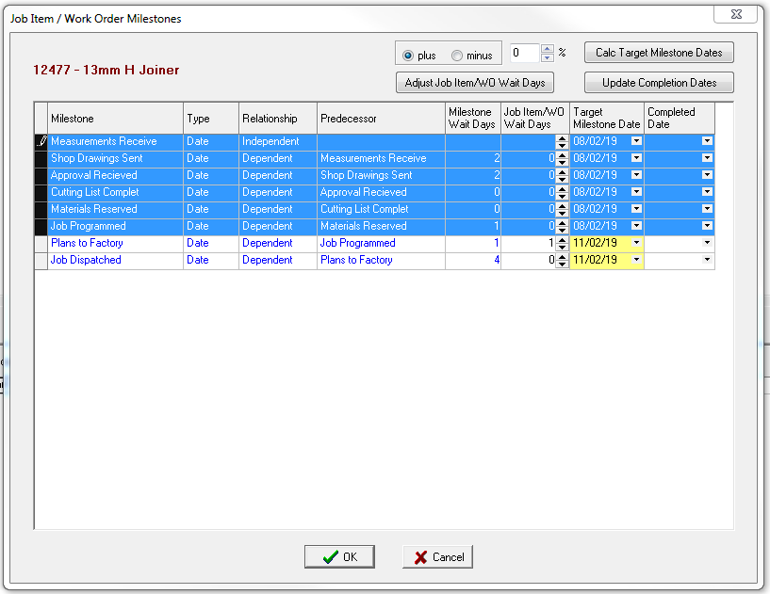
18. Click Update Completion Dates  
    
19. Leave “Set completion date to it’s target milestone date” selected and click OK  
    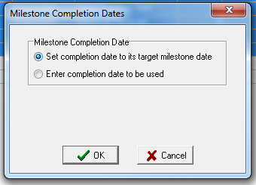
20. All milestone dates are now set up. Click OK to save the changes.  
    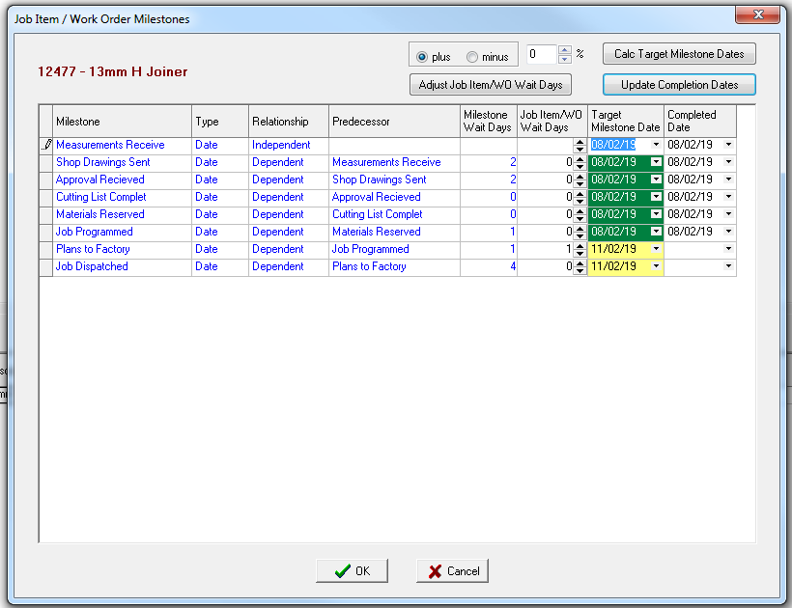
21. WO can continue processing & manufacture now.  
    